**Module - 3 (Context Based Testing)**

**What is load testing?**

Load Testing is a non-functional software testing process in which the performance of software application is tested under a specific expected load. It determines how the software application behaves while being accessed by multiple users simultaneously. The goal of Load Testing is to improve performance bottlenecks and to ensure stability and smooth functioning of software application before deployment.

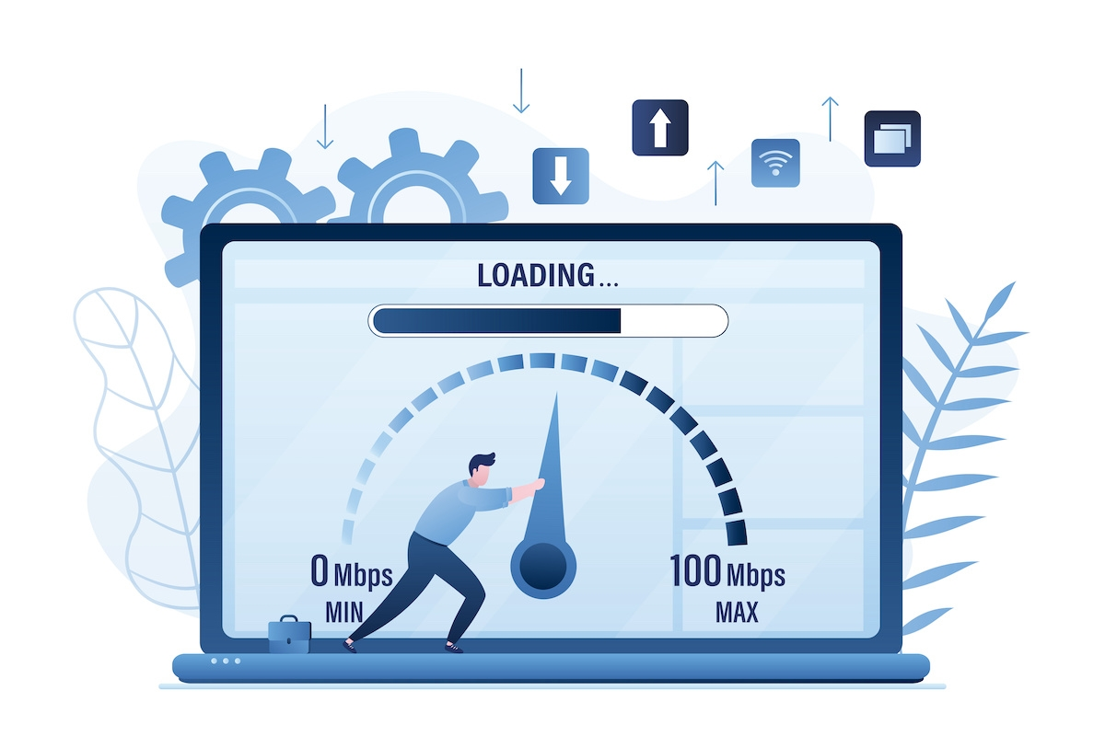

**This testing usually identifies –**

* The maximum operating capacity of an application
* Determine whether the current infrastructure is sufficient to run the application
* Sustainability of application with respect to peak user load
* Number of concurrent users that an application can support, and scalability to allow more users to access it.

It is a type of non-functional testing. In Software Engineering, Load testing is commonly used for the Client/Server, Web-based applications – both Intranet and Internet.

**What is Stress Testing ?**

Stress Testing is a type of software testing that verifies stability & reliability of software application. The goal of Stress testing is measuring software on its robustness and error handling capabilities under extremely heavy load conditions and ensuring that software doesn’t crash under crunch situations. It even tests beyond normal operating points and evaluates how software works under extreme conditions.



In Software Engineering, Stress Testing is also known as Endurance Testing. Under Stress Testing, AUT is be stressed for a short period of time to know its withstanding capacity. A most prominent use of stress testing is to determine the limit, at which the system or software or hardware breaks. It also checks whether the system demonstrates effective error management under extreme conditions.

**Write a scenario of only Whatsapp chat messages**

* Check the Chat window that contains the entire chat list.
* Check the Chat window displays the contact numbers whose numbers are not saved on mobile.
* Check the Chat window displayed with all contacts with DP or without DP
* Check the Chat window is displayed on the group chat list.
* Check the Chat window displays the last updated chatting time.
* Check the Chat window displays the name of all contacts on the chat window.
* Check the clicking on one Chat contact then a new window should open with history.
* Check the user can see all delivered and received messages.
* Check the user can see the read or send time of messages.
* Check the user can send and receive text messages in the individual chatbox.
* Check the user can send and receive documents in the individual chatbox.
* Check the user can send and receive photos in an individual chatbox.
* Check the user can send and receive videos in an individual chatbox.
* Check the user can send and receive audio in an individual chat box.
* Check the user can send and receive emotions icons in the individual chat boxes.
* Check the user can send and receive Contacts in the individual chat boxes.
* Check the user can send and receive Location in the individual chatbox.
* Check the user can send and receive GIFs in the individual chat boxes.
* Check the user can send and receive Stickers in the individual chatboxes.
* Check the user can delete text, video, audio, locations, and documents in the individual chatboxes.
* Check the user can send recorded voice mail in an individual chatbox.
* Check the user can delete the entire chat history in the individual chatbox.
* Check the user is able to see contact details in the individual chat box.
* Check the user is able to share images, links, and documents from media in the individual chatboxes.
* Check the user is able to search specific chat history using the search option in the individual chatbox.
* Check the user is able to video call in the individual chat box.
* Check the user is able to voice call in the individual chat box.
* Check the user is able to mute the individuals in the individual chat boxes.
* Check the user is able to change the wallpaper.
* Check the users have options like Report, Block, Clear Chat, Export Chat, and Add Shortcut.

**Write a Scenario of Pen**

* Verify that the length and the diameter of the pen are as per the specifications.
* Verify the outer body material of the pen. Check if it is metallic, plastic, or any other material specified in the requirement specifications.
* Check the color of the outer body of the pen. It should be as per the specifications.
* Verify that the brand name and/or logo of the company creating the pen should be clearly visible.
* Verify that any information displayed on the pen should be legible and clearly visible.
* types of papers.
* Check the weight of the pen. It should be as per the specifications. In case not mentioned in the specifications, the weight should not be too heavy to impact its smooth operation.
* Verify if the pen is with a cap or without a cap.
* Verify the color of the ink of the pen.
* Check the odor of the pen’s ink on writing over a surface.
* Verify the surfaces over which pen is able to write smoothly apart from paper e.g. cardboard, rubber surface, etc.
* Verify that the text written by the pen should have consistent ink flow without leaving any blob.
* Check that the pen’s ink should not leak in case it is tilted upside down.
* Verify if the pen’s ink should not leak at higher altitudes.
* Verify if the text written by the pen is erasable or not.
* Check the functioning of the pen on applying normal pressure during writing.
* Verify the strength of the pen’s outer body. It should not be easily breakable.
* Verify that text written by pen should not get faded before a certain time as mentioned in the specification.
* Check if the text written by the pen is waterproof or not.
* Verify that the user is able to write normally on tilting the pen at a certain angle instead of keeping it straight while writing.
* Check the grip of the pen, whether it provides adequate friction for the user to comfortably grip the pen.
* Verify if the pen can support multiple refills or not.
* In the case of an ink pen, verify that the user is able to refill the pen with all the supported ink types.
* For ink pens, verify that the mechanism to refill the pen is easy to operate.
* In the case of a ballpoint pen, verify the size of the tip.
* In the case of a ball and gel pen, verify that the user can change the refill of the pen easily.

**Write a Scenario of Door**

* Check whether the door is made up of wood or glass or any other material
* Check the door is a leading door washroom door any other location door
* Check if the door is built with glass then it is a transparent or non-transparent door
* Check if there are any levels present on the door like push or pull
* Check which type of door, whether it is a single door or a folded door.
* Check the door is open on which side, Whether it is inside or outside.
* Check the size of the door is as per the specification document
* Check the door is made upon the same material which was mentioned in the specification document
* Check whether the color of the door is the same as the specification document
* Check the opening functionality of the door whether that is a sliding door or a rotating door
* Check the design of the door is as per the specification document
* Check the position, quality, and strength of the hinges
* Check what type of logs are present in the door
* Check the number of locks current inside and outside of the door
* Check whether the big hole door has a peek-hole, and also check the position of that whole is as per the specification document
* Check is the door has automatic close functionality in it, and your automatic feature represents the spring mechanism
* Check whether the door has a stopper at the correct location Which is mentioned in the specification document
* Check whether the door makes any sounds while opening or closing
* Check the door condition when you are washing with hot water or cold water
* Check the door condition and different climates like summer winter rain etc
* Check how much amount of force is required to open or close the door

**Write a Scenario of ATM**

* Verify the ‘ATM Card Insertion Slot’ is as per the specification
* Verify the ATM machine accepts card and PIN details
* Verify the error message by inserting a card incorrectly
* Verify the error message by inserting an invalid card (Expired Card)
* Verify the error message by entering an incorrect PIN
* Verify that the user is asked to enter the PIN after inserting a valid ATM Card
* Verify that PIN is encrypted
* Verify that there is an action like blocking of card occurs when the total no. of incorrect PIN attempts get surpassed
* Verify the user is allowed to do only one cash withdrawal transaction per PIN request
* Verify the machine logs out of the user session immediately after successful withdrawal
* Verify the message when there is no money in the ATM
* Verify the language selection functionality
* Verify the cash withdrawal functionality by entering some valid amount
* Verify the cash withdrawal functionality by entering an amount less than 100
* Verify the cash withdrawal functionality by entering an amount greater than the total available balance in the account.
* Verify the cash withdrawal functionality by entering an amount greater than per day limit
* Verify the user is allowed to enter the amount again in case the amount entered is not valid. A proper message should be displayed.
* Verify the ATM machine successfully takes out the money.
* Verify the ATM machine takes out the balance printout after the withdrawal
* Verify the font of the text displayed in ATM screen
* Verify the text on the screen buttons visible clearly.
* Verify the functionality of all the buttons on the keypad
* Verify the text on the buttons visible clearly.
* Verify that touch of the ATM screen is smooth and operational
* Verify the user is allowed to choose different account types like Savings, Current etc.,
* Verify the different combinations of operation and check if there will be an electricity loss in the middle of the operation. If there is an electricity loss in the middle of the transaction then the transaction should be marked as null and the amount shouldn’t be disclosed to others.
* Verify the functionality of the cash dispenser
* Verify the functionality of the receipt printer
* Verify whether the printed data is correct or not in the receipt
* Verify how much time the system takes to log out.

**When to used Usablity Testing?**

If possible, usability testing can and should be conducted on the current iteration of a product before beginning any new design work, after you’ve begun the strategy work around a brand new site or app. This will quickly identify areas for opportunity, and reduce the amount of assumptions your design team will make with regard to what the user wants. Additionally, after the usability tests analysis, the team should have the ability to pinpoint the steps needed to achieve the project goals with as little disruption as possible.

**What is the procedure for GUI Testing?**

GUI Testing Techniques can be categorized into three parts:

**Manual Based Testing**

Under this approach, graphical screens are checked manually by testers in conformance with the requirements stated in the business requirements document.

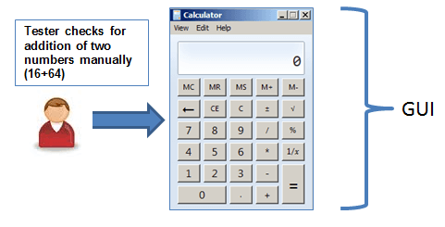

**Record and Replay**

GUI testing can be done using automation tools. This is done in 2 parts. During Record, test steps are captured by the automation tool. During playback, the recorded test steps are executed on the Application Under Test. Example of such tools – QTP.

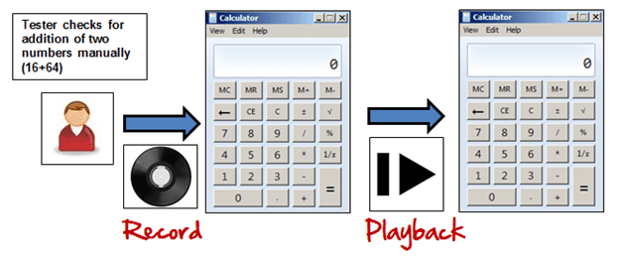

**Model Based Testing**

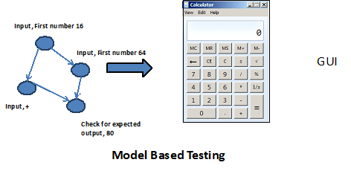

A model is a graphical description of a system’s behavior. It helps us to understand and predict the system behavior. Models help in a generation of efficient test cases using the system requirements. The following needs to be considered for this model based testing:

* Build the model
* Determine Inputs for the model
* Calculate the expected output for the model
* Run the tests
* Compare the actual output with the expected output
* A decision on further action on the model

**Some of the modeling techniques from which test cases can be derived:**

* Charts – Depicts the state of a system and checks the state after some input.
* Decision Tables – Tables used to determine results for each input applied

**Write a scenario of Microwave Owen**

* Check the structure and dimensions of the microwave and see if it conforms to the specified dimensions mentioned in the user manual.
* Check if the door of the oven fits squarely and securely and opens and closes smoothly.
* Check if the door hinges are in proper condition and if the surface of the door is not damaged.
* Check if there is no corrosion evident on the door, the door hinges, or the oven interior.
* Plug the power terminal and see if the LED glows. And test if the oven is getting power supply. Also, test the current received and maximum allowed.
* Check if the microwaves generated in the microwave oven cease to exist once the electrical power to the magnetron is turned off.
* Check how the microwave performs under different voltage conditions. Test how it is able/unable to sustain fluctuating voltage.
* Check the power consumption of the microwave.
* Switch ON the oven for a very long time (say up to 12-24 hours continuously) and see the result. Test if the thermostat works fine under such a situation.
* Check if the timer is working, and the microwave switches off automatically after the preset time.
* Keep the oven door open and test if you can set a timer for cooking.
* Check if you can switch off the microwave before the timer has counted down to the present time.
* Check the cooking time for different food items.
* Check if the oven results in uneven absorption causing localized “hot spots”.
* Check if the bowls made up of glass and plastics are heated when used in the oven. Ideally, they should not.
* Check if parts of frozen food remain frozen if insufficient time is allowed for the heating process.
* Check if microwaves do not directly heat the oven walls and other non-metallic cooking utensils.
* Check if microwave exposure causes serious health effects such as deep tissue burns and hyperthermia. Test if it either causes or promotes cancer.
* Check if the microwaves make the food or the oven radioactive.
* Test if the safety interlock switches stop the generation of microwaves immediately after the door is opened.
* Test that there is no microwave leakage from the device. If it is there, it should not exceed the recommended limit (differs from country to country).
* Test if cardiac pacemakers are likely to be susceptible to microwave interference, when very close to an oven.
* Test the operation of the oven without a load (i.e., an absorbing material such as food or water). See if it results in fire hazards due to the resonance of the magnetron tube itself.
* Test by using the oven for sterilizing baby bottles or other food utensils.
* Test if closed containers and eggs explode when heated in the microwave oven due to the pressure build-up of steam.
* Try to heat grapes in the oven and see if it explodes due to arcing!

**Write a scenario of Coffee vending Machine**

* Check if the power button of the coffee vending machine is working correctly after pressing the power button.
* Check the indicator lights are displaying correctly when the coffee vending machine is going to switch off or on.
* Check all the buttons of the coffee vending machine have an image text on them, which indicates what task will be performed if you press the button.
* Check the complete quantity of copy poured hey in a single operation, and noo coffees are stored in the nozzle area.
* Check the former up the coffee vending machine is working as expected
* Check the temperature of is served coffee should be the same temperature
* Check if some ingredients if finished. Then it should display an error message on the LED screen.
* Check if a button is pressed multiple times, then the operation should be performed multiple times if you have pushed the button five times the coffee button then five coffee should be served
* Check the time they take to serve coffee should be the same as mentioned in the specification document
* Check there should be a button for passes for extra coffee in the machine
* Check if the coffee vending machine is built as per the specification document.
* Check if the outer body of the coffee vending machine looks similar. Is it described in the specification document?
* Check if this product is built with all the materials which are described in the specification document.
* Check if the brand logo is visible in the specification document.
* Check if the input mechanisms of coffee vending machines Like milk, what, and coffee beans are working correctly.
* Check in the coffee, the quantity of water and coffee beans, and the milk mix as expected.
* Check how much power the coffee vending machine consumes if the consumable power is equal to the authority mentioned in the specification document.
* Check if the power is off is a sudden processing request for a coffee generation, then the machine should stop immediately, and the remaining coffee should not come out from the nozzle.
* Check if is there any leakage when the coffee vending machine is in standby mode.
* Check the amount of coffee served should be equal to the specification.
* Check all the buttons present on the coffee vending machine are working correctly.
* Check the LED display attached to the coffee vending machine should display the correct information list up.
* Check for the cup holder dimension as per specification/ or market standard
* Check the performance of the device when used continuously until the ingredients run out of the requirements.
* Check the performance of the coffee vending machine when there is low voltage or high voltage
* Check the number of times taken by the machine to service a single coffee.

**Write a scenario of chair**

* Check the material used for making the chair is as per the requirement document.
* Check if the dimension of the chair is as per the specification document.
* Check if the dimension of the weight is as per the specification document.
* Check if the dimension of the height is as per the specification document.
* Check the number of legs of a chair.
* Check the chair backrest option.
* Check that all legs of the chair on a plane surface are equal or not.
* Check if the chair is compatible for taking rest.
* Check whether a human is able to sit comfortably or not on a chair.
* Check if the chair has an adjustment functionality or not.
* Check the sitting space as per mentioned in the requirement document.
* Check the legs of the chair is having any wheels or not.
* Check if the chair is good enough to handle some specified amount of load.
* Check what is the maximum amount of load the chair is handling.
* Check the date is stable enough to take any human load.
* Check the color of the table is as per the SRS documents.
* Check the type of chair, for example, Office chair, Dining room chair, Dentist chair, Beanbag chair, Swing chair, Public benches or Armchair…….etc.

**To Create Scenario (Positive & Negative)**

1. **facebook Chat on Mobile**

* Check the received messages counts should be displayed on the ‘Facebook Message’ icon
* Check the user gets all received messages in his inbox.
* Check that only ‘message contacts’ will display on the left-hand side of the message box
* Check the profile picture display on the left-hand side of the inbox is correct for each user
* Check ‘Active’ users display with a green dot in the message box
* Check unread messages are highlighted so that the user can identify it
* Check received messages counts should be displayed with Inbox on the ‘Messages’ page
* Check messages will get displayed in the Inbox of ‘User1’ only when ‘sender’ is connected with user1 on Facebook
* Check messages will get displayed in the ‘Other’ tab of ‘User1’ if ‘sender’ is not connected with user1 on Facebook
* Check the user can search contacts in the message box
* Check the behavior of the chatbox if we change the network from Wi-Fi to LAN
* Check the user is able to navigate to the old conversation or can view message history
* Check the user is able to send a new message to a friend selected from the list present on the left-hand side
* Check the message gets sent after clicking on the entering button
* Check copy, and paste works in the chatbox or not
* Check whether the user is able to send special characters in Chat or not.
* Check that the User is able to share hyperlinked URLs, Emails, or not.
* Check how many words or characters can be sent at a time.
* Check that spell functionality works fine in the chatbox
* Check if the user enters a message in the textbox and clicks on the refresh button without sending it
* Check that the user is able to send smiley
* Check that the user is able to send multiple smiles at a time
* Check that if the user types smile in letters then it will look like their icon or not
* Check that the User is able to share images
* Check that an error message should get displayed after uploading an image of an unsupported type
* Check that the User is able to share videos
* Check that the User is able to share files
* Check error message should get displayed after uploading large size files
* Check that the user is able to send messages in local languages
* Check that if the user has typed any message and navigated to another tab without sending it then the message should not get removed
* Check that the user gets the appropriate message if the internet goes down while sending a message
* Check that the user is able to view which device has been used to send a message.
* Check that the user is able to delete the sent message
* Check that the user is able to delete multiple messages at a time
* Check that the user is able to view his sent messages on different devices
* Check that ‘loader’ will get displayed if message sending takes time due to connection issues
* Check that the User is able to send messages to other offline Users.
* Check that the User is able to send messages to requests to other users who are not on the contact list
* Check that the user can send direct messages to anyone from the contact list
* Check by Log into Facebook more than 2 devices at a time and try to send messages>>Sent message lists and message contact list should get updated/refreshed on every device that has logged in

1. **Gmail (Receiving mail)**

* Verify that a newly received email is displayed as highlighted in the Inbox section.
* Verify that a newly received email has correctly displayed sender email Id or name, mail subject and mail body(trimmed to a single line).
* Verify that on clicking the newly received email, the user is navigated to email content.
* Verify that the email contents are correctly displayed with the desired source formatting.
* Verify that any attachments are attached to the email and are downloadable.
* Verify that the attachments are scanned for viruses before download.
* Verify that all the emails marked as read are not highlighted.
* Verify that all the emails read as well as unread have a mail read time appended at the end on the email list displayed in the inbox section.
* Verify that count of unread emails is displayed alongside ‘Inbox’ text in the left sidebar of Gmail.
* Verify that unread email count increases by one on receiving a new email.
* Verify that unread email count decreases by one on reading an email ( marking an email as read).
* Verify that email recipients in cc are visible to all users.
* Verify that email recipients in bcc are not visible to the user.
* Verify that all received emails get piled up in the ‘Inbox’ section and get deleted in cyclic fashion based on the size availability.
* Verify that email can be received from non-Gmail email Ids like – yahoo, Hotmail etc.

1. **Online shopping to buy product (flipkart)**

* Check is the home page should be displayed after a successful login or not.
* Check if the user name is displayed on the homepage or not.
* Check if the home page is in different browsers.
* Check is the products are displayed on the home page or not.
* Check if the search functionality is available on the home page or not.
* Check if products on the home page are clickable or not.
* Check the alignment on the home page.
* Check is the products are displayed as categorized on the home page or not.
* Check if the user profile is available on the home page or not.

**Write a Scenario of Wrist Watch**

* Verify the wrist watch type - whether it is Analog wrist watch, Digital wrist watch or Smart wrist watch.
* Verify that watch shows the correct time or not on the basis of region.
* Check that user is able to set the time or change the time or not on a wrist watch.
* Check that user is also able to change the day on wrist watch if it is available.
* Check that all the parts of wrist watch are properly fitted or not.
* Verify that the Date, Time and other information in a wristwatch is properly visible to the user not.
* Verify the watch properly fit on the wrist or not.
* Check the design of wrist watch as per requirement or not.
* Verify if the watch is waterproof.
* Verify the colour, width, dial, and length of wrist watch as per CRS or not.
* Verify that the materials used for the wrist watch body are as per requirement or not.
* Verify the material used for wrist watch strap -Plastic , leather .etc
* Verify the wrist watch weight as per requirement or not.
* Verify the Logo and name of company showing properly or not on watch.
* Verify the functionality of the button of the watch working fine or not.

**Write a Scenario of Lift(Elevator)**

* Verify the dimensions of the lift
* Verify the type of door of the lift is as per the specification
* Verify the type of metal used in the lift interior and exterior
* Verify the capacity of the lift in terms of the total weight
* Verify the buttons in the lift to close and open the door and numbers as per the number of floors
* Verify that lift moves to the particular floor as the button of the floor is clicked
* Verify that lift stops when up/down buttons at particular floor are pressed
* Verify if there is an emergency button to contact officials in case of any mishap
* Verify the performance of the floor – the time is taken to go to a floor
* Verify that in case of power failure, lift doesn’t free-fall and get halted in the particular floor
* Verify lifts working in case button to open the door is pressed before reaching the destination floor
* Verify that in case door is about to close and an object is placed between the doors if the doors sense the object and again open or not
* Verify the time duration for which door remain open by default
* Verify if lift interior is having proper air ventilation
* Verify lighting in the lift
* Verify that at no point lifts door should open while in motion
* Verify that in case of power loss, there should be a backup mechanism to safely get into a floor or a backup power supply
* Verify that in case multiple floor number button is clicked, lift should stop at each floor
* Verify that in case of capacity limit is reached users are prompted with warning alert- audio/visual
* Verify that inside lift user are prompted with current floor and direction information the lift is moving towards- audio/visual prompt

**Write a Scenario of whatsapp group (generate group)**

* Check whether the user is able to create a new one or not.
* Check the user is able to add multiple contacts from the contact list.
* Check the user is able to insert the group name and select an image for DP.
* Check the user is able to add and remove contacts from the group.
* Check the user is able to delete a group.
* Check the user can send and receive text messages in the group.
* Check the user can send and receive documents in the group chat box.
* Check the user can send and receive photos in the group chat box.
* Check the user can send and receive videos in the group chat box.
* Check the user can send and receive audio in the group chat box.
* Check the user can send and receive emotions icons in the group chat box.
* Check the user can send and receive Contacts in the group chat box.
* Check the user can send and receive Location in the group chat box.
* Check the user can send and receive GIFs in the group chat box.
* Check the user can send and receive Stickers in the group chat box.
* Check the user can delete text, video, audio, locations, and documents in the group chat box.
* Check the user can send recorded voice mail in the group chat box.
* Check the user is able to make multiple video call in the group chat box.
* Check the user is able to see the group contact information from Group Info in the group chat box.
* Check the user is able to share images, links, and documents from Group Media in the group chat box.
* Check the user is able to search specific chat history using the search option in the group chat box.
* Check the user is able to mute the group in the group chat box.
* Check the users have options like Report, Block, Clear Chat, Export Chat, and Add Shortcut.